Emailed Thomas Phillips – Message Marked High Importance. No Response.
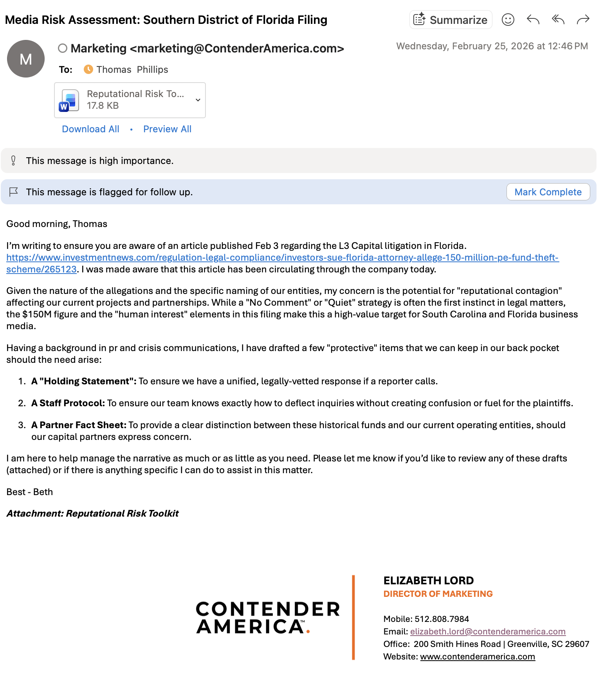

EMAIL ATTACHMENT:
Reputational Risk Tookit – Control and Contain
These documents are drafted to be professionally detached, legally cautious, and focused entirely on protecting the current business assets (Contender and Blackstream) from the allegations surrounding the L3 Funds.
Item 1: The Reactive Media Statement (For Media/External Use)
This is a "reactive" statement. It should never be sent out proactively, but kept for when a reporter, or an external party, calls and demands a comment. Think of this as our ‘break glass in case of emergency’ response. It is a legally-cautious ‘no-comment’ that still defends the integrity of the firm without opening us up to further questioning.
"We are aware of the civil filing in the Southern District of Florida regarding historical fund structures. The allegations involve complex legal matters that are currently being addressed through the proper judicial channels. While we do not comment on active litigation, the leadership of Contender and the Blackstream entities categorically denies these claims and intends to defend their professional reputations vigorously. Our focus remains entirely on our current operations and our commitment to our partners and the success of our active projects."

Item 2: The Staff Protocol (Internal "Lockdown" Guide)
This is for your internal use to ensure no employee inadvertently creates "discoverable" evidence or fuels a news story. This ensures our team doesn’t inadvertently fuel a story or say something that complicates the legal defense. It is a polite way to hang up the phone and route the caller to a single, controlled point of contact.
MEMORANDUM: PROTOCOL FOR EXTERNAL INQUIRIES
Purpose: To ensure that all company communications are accurate, unified, and legally protected.
The Directive: Effective immediately, no employee is authorized to discuss, comment on, or provide information regarding any pending legal matters involving the company or its leadership.
Standard Response Procedure: If you receive a phone call or email from a reporter, an investigator, or an unknown party asking about "the Florida lawsuit" or "L3 Funds," please use the following script:
"Thank you for reaching out. I am not the authorized spokesperson for that matter. I can take your name, organization, and contact information and ensure it is directed to the appropriate department for a formal response."
Additional Requirements:
Do Not Speculate: Do not offer personal opinions on the "fairness" of the claims or the characters involved.
Social Media Silence: Do not engage with, "like," or comment on any news articles or social media posts related to the litigation.
Report All Contact: Immediately notify Elizabeth Lord, Director of Marketing of any inquiry received, including the name of the caller and the nature of their questions.

Item 3: Stakeholder Fact Sheet (Distinction & Insulation)
Stakeholder FAQs: This is a high-level document intended for your most important capital partners or lenders who may see the $150M figure and react. It focuses on "Asset Insulation."
STRATEGIC UPDATE: LITIGATION OVERVIEW & OPERATIONAL CONTINUITY
Core Distinction: The civil litigation filed on February 2, 2026, concerns the historical management and fee structures of the L3 Capital Income Fund, L3 Capital Hotel Fund, and L3 Capital Special Opportunity Fund. It is critical to note that these funds are distinct and separate legal entities from the ongoing operations of Contender and the Blackstream entities.
Key Mitigating Factors:
- Entity Separation: The assets and management of our current projects are not commingled with the L3 Funds named in the suit.
- Professional Integrity: Ford Elliott, Carlos Salgado, and Joshua Howard have built a track record of operational success. They deny the allegations in the Florida filing and are represented by counsel to resolve the matter through the federal court system.
- Operational Stability: There are no planned changes to the management, staffing, or strategic direction of our current entities. Our fiduciary duty to our current partners remains our highest priority.
Conclusion: We remain transparent with our partners and are committed to ensuring that external legal disputes do not distract from the performance and security of our shared assets.

